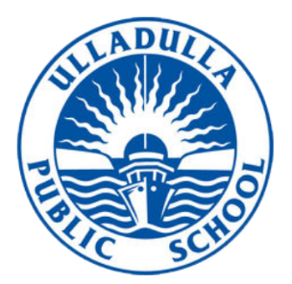
ULLADULLA PUBLIC SCHOOL

Excellence, Innovation, Opportunity, Success, Strong Values
Principal: Mr Trent Burns
Ph: (02) 4455 1649
Email: ulladulla-p.school@det.nsw.edu.au

Getting ready for a great start in 2019

Ulladulla Public School is making sure all students have the chance to make a great start to 2019, whether they are new to the school or coming back.

We want every student to make a strong start in education by being fully engaged in their learning and challenged to do their best, in a safe, supportive environment.

The information families need about how to prepare for the new school year, including all the different ways parents can participate, and how to get to know our teachers, is on our website:
https://ulladulla-p.schools.nsw.gov.au/

As well as general advice, the website has practical information including starting dates for the different years, school hours, uniform information, advice about books and other supplies, voluntary contributions, hot weather practices and information about transport and drop-off zones.

Ulladulla Public School is part of the local community, and has always appreciated the support it receives from the community.

We strongly encourage parents and carers to find out about what their children are learning and how they are learning, and to know how we support our students through our wellbeing programs including anti-bullying, cyber-safety and behaviour policies.
In 2019 we will embark on Challenging Learning Process as a whole staff. This means that we will be implementing ‘best practice’ in every classroom to challenge our students thinking, to give feedback that impacts, to provide a language of learning and promote a ‘growth mindset’. We will continue our school-wide ‘Soundwaves’ phonemic awareness program to enhance students’ reading and spelling development. We will also be implementing our new Science and Technology syllabus.
Alongside learning about the living world, the material world, the physical world and earth and space, students will now learn about digital technologies including Coding. Our school library, computer LAB and classrooms will undergo changes in space design. These exciting changes will allow for flexible learning environments to encourage collaborative learning.
These are some of the exciting directions that will benefit your child’s learning in 2019.
Starting school is a big event in any Kindergarten child’s life, and a good start will influence the rest of their school career. There is sound and practical advice on the Department of Education’s Back to School hub at education.nsw.gov.au/backtoschool.

Our teachers and support staff at Ulladulla Public School are looking forward to seeing new and existing students, offering new opportunities, working together with parents and carers for a great start to 2019.

Trent Burns
Principal

